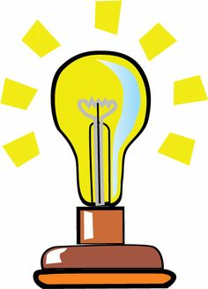
Describing Differences
Solutions
We use ‘in contrast to’, ‘in comparison to’, ‘is different from’, ‘differs from’ and ‘unlike’ to explain differences between two things.
in contrast to differs from unlike different from in comparison to whereas

1. Use the phrases in the box to complete these sentences:
a) Sugar is a soluble substance _________________ sand which is an insoluble substance. Another example of a/an soluble substance is
_________________ and another example of a/an insoluble substance is _____________________________________

b) Soluble substances will dissolve __________________ insoluble substances will not dissolve.

c) In a solution, the solute is the thing that dissolves ______________
the solvent that is the thing doing the dissolving. An example of a solute is _____________________ and an example of a solvent is ___________

d) A centrifuge is a device that spins to separate solids from liquids, or liquids from liquids, this ____________________ decantation which involves separation by pouring liquid off the top of a mixture. Name a common household device which uses centrifuge ___________________

e) Evaporation is used to collect a dissolved solute only which is
_______________________ distillation which collects both the solvent and solute.

f) Sand could be removed from water by filtration _______________
_________ salt which would need to be removed by evaporation.

